*75%*

*Using your textbook, labs and the internet complete the following test in 2 hours or less. All code submitted must be your original work.*

*Please create all three projects under one solution. Upload Completed work to GitHub.*

1. [30 pts] Write a GUI-based program that converts distances between inches and centimeters.

* The program must contain a constant named **CM_PER_IN** which holds the number of inches per centimeter (2.54 cm per inch).
* Prompt the user for a distance in inches.
* Once the user presses a button, display the distance in both inches and centimeters as follows: **“2 inches is 5.08 centimeters”**

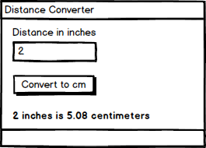

1. [30 pts] Write a GUI-based program that asks the user for a GPA between 0.0-4.0 and converts it to a letter grade using the following conversion table:

|  |  |
| --- | --- |
| **Numeric grade** | **Letter grade** |
| grade > 3.0 | A |
| 3.0 ≥ grade > 2.0 | B |
| 2.0 ≥ grade > 1.0 | C |
| 1.0 ≥ grade > 0.0 | D |
| grade ≤ 0.0 | F |

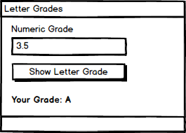

1. [40 pts] Write a GUI-based program for a lawn-mowing service.

* The lawn-mowing season lasts 20 weeks.
* The fee for a lot that is 600 square feet or more is $50 per week.
* The fee for a lot that is 400 square feet or more, but under 600 square feet, is $35 per week.
* The weekly fee for mowing a lot under 400 square feet is $25.
* Prompt the user for the length and width of a lawn in feet.
* *Display the total area of the lawn in square feet.*
* *Display the weekly mowing fee.*
* *Display the total fee for the 20-week season.*

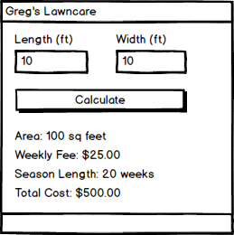

**Grading**

All projects are located in 1 solution - **10pts**

EX1 – Uses a GUI-based interface – **5 pts**

EX1 – Contains a constant named CM_PER_IN – **5 pts**

EX1 – Accepts a distance in inches from the user – **5 pts**

EX1 – Converts the distance to centimeters correctly – **10 pts**

EX1 – Displays the output in the desired format – **5 pts**

EX2 – Uses a GUI-based interface – **5 pts**

EX2 – Conditional statements run without syntax errors – **5 pts**

EX2 – Produces correct output for each of the 5 letter grades – **3 points each**

EX3 – Uses a GUI-based interface – **5 pts**

EX3 – Conditional statements run without syntax errors – **5 pts**

EX3 – Accepts the length and width of the lawn in feet – **5 pts**

EX3 – Displays correct lawn area in square feet – **5 pts**

EX3 – Displays correct weekly and total fees for each of the 3 lawn size categories – **5 points each**